
DTSC-625: Data Engineering in the Cloud
Curtis Nielson

Lambda Lab CSV-to-Parquet

Complete the following template and upload to the assignment on Brightspace.

In every screenshot, include your AWS username that appears in the upper right corner. You must use either your full name or your Eastern University email address as your AWS username. Example:

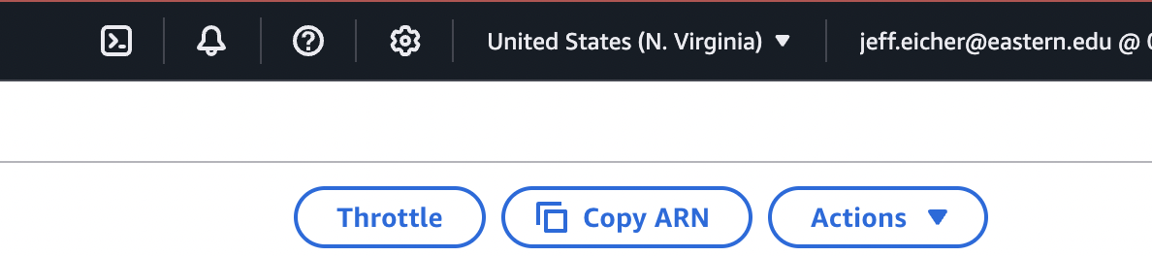

If any one screenshot is missing this identification, the entire assignment will be scored no higher than 70%.

Points totals are provided at the start of each question. You score either full credit or 0 points; there is no partial credit for each question.

- [30 points] In the space below, provide a screenshot of the permissions assigned to your role for the Lambda function, showing the updated JSON with your bucket names (from Step 2).
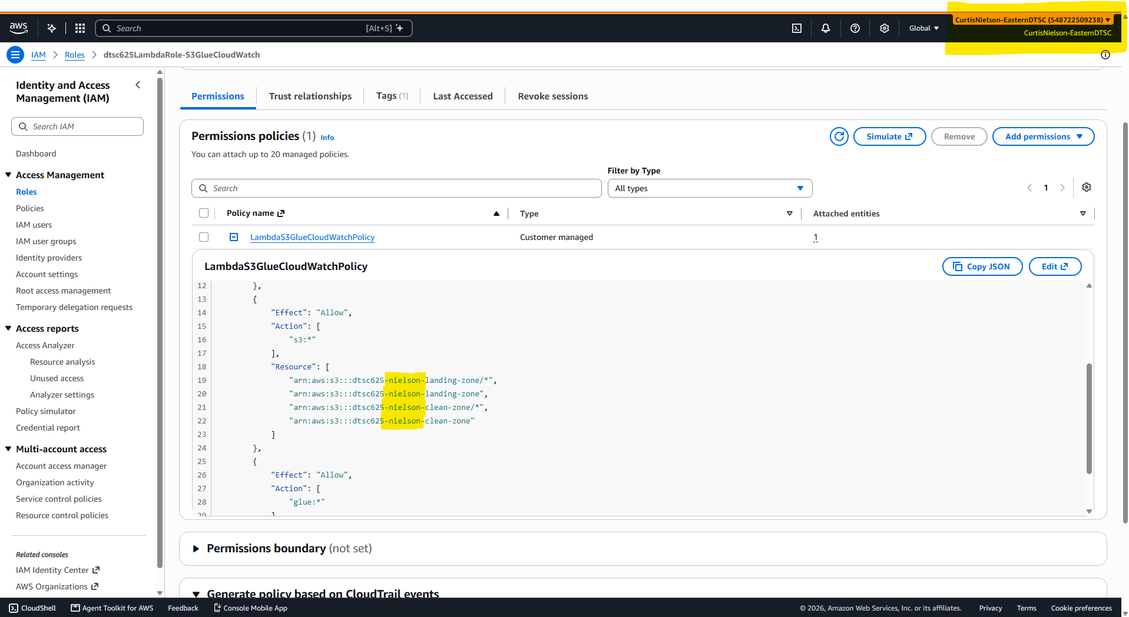

- [30 points] In the space below, provide a screenshot of your Lambda function code. Use multiple screenshots if you can’t fit all the code in one screenshot.
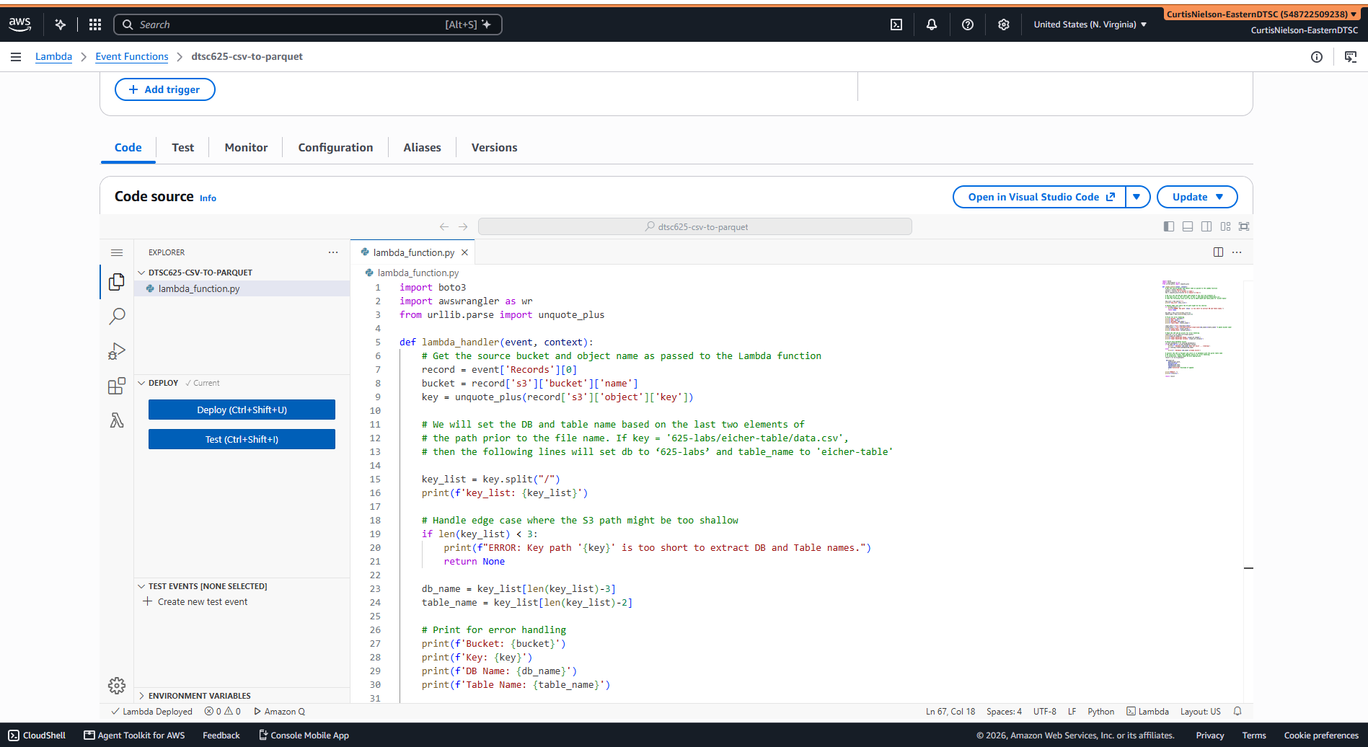
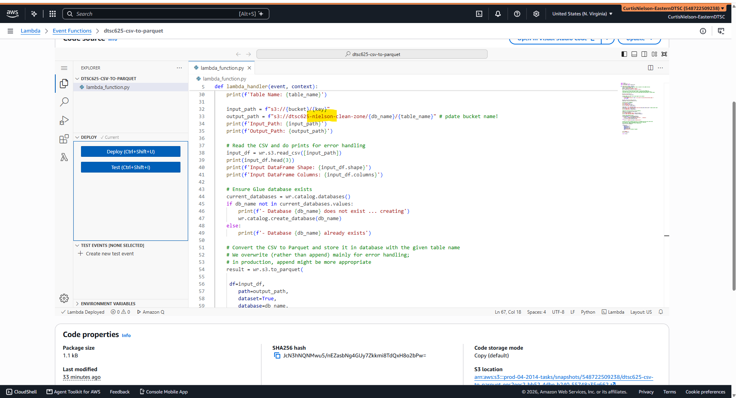
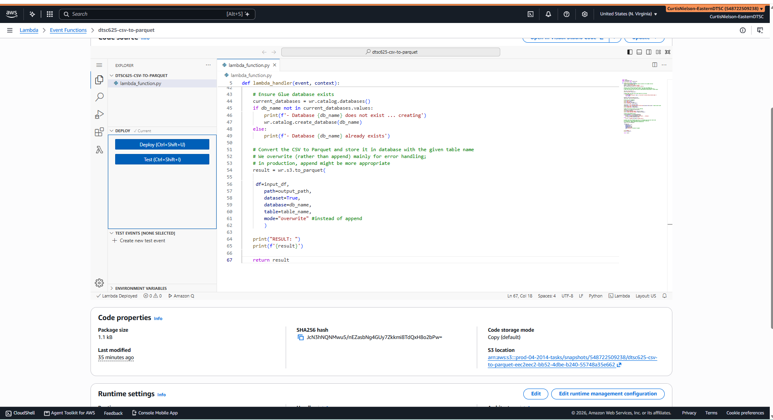

- [40 points] In the space below, provide a screenshot of the sc_ap2021 file (now a parquet file) in the appropriate folder within your clean_zone S3 bucket.



